5.1.4 Students benifitted by Guidance for competitive examinations and career counseling offered by the Institution

CA Foundation Coaching
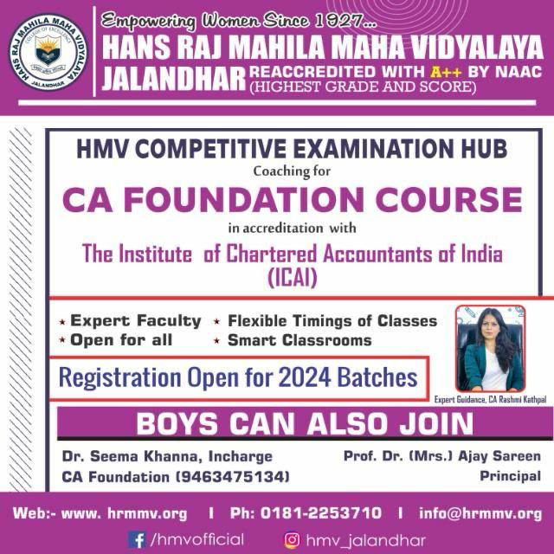

Workshop on Aptitude and reasoning on 01-07-2023

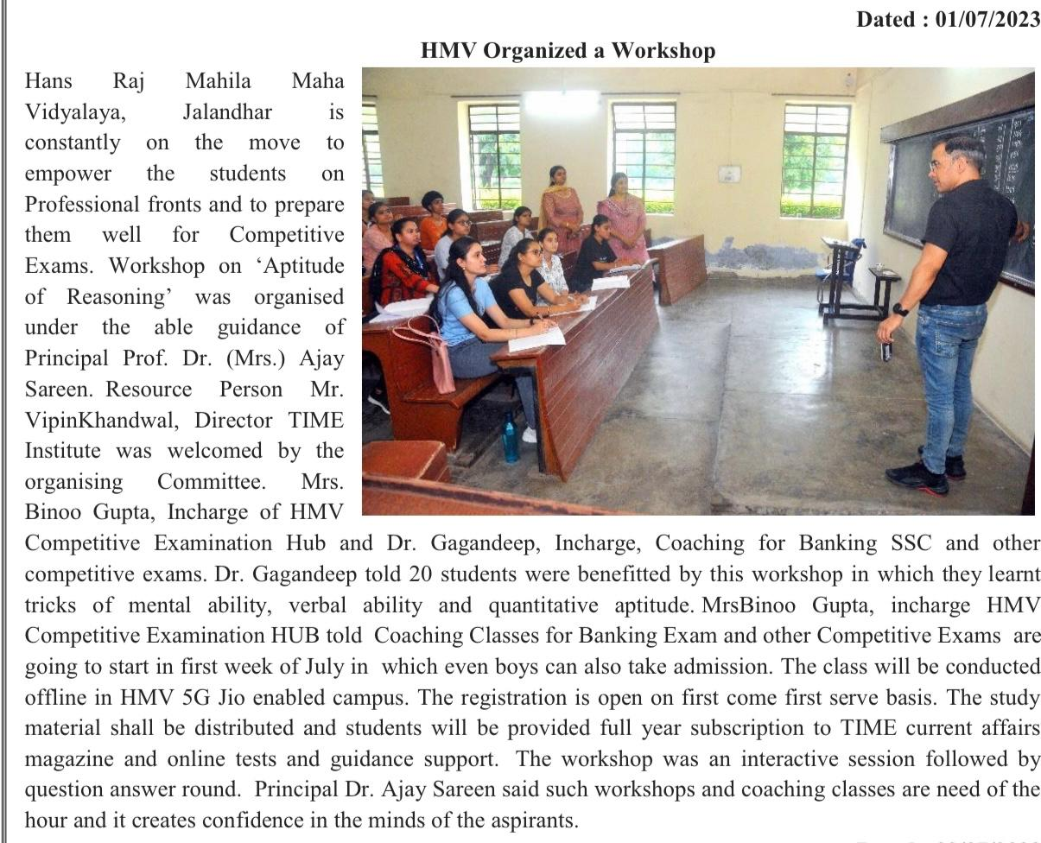

Seminar on Future Skills Prime on 19-07-2023

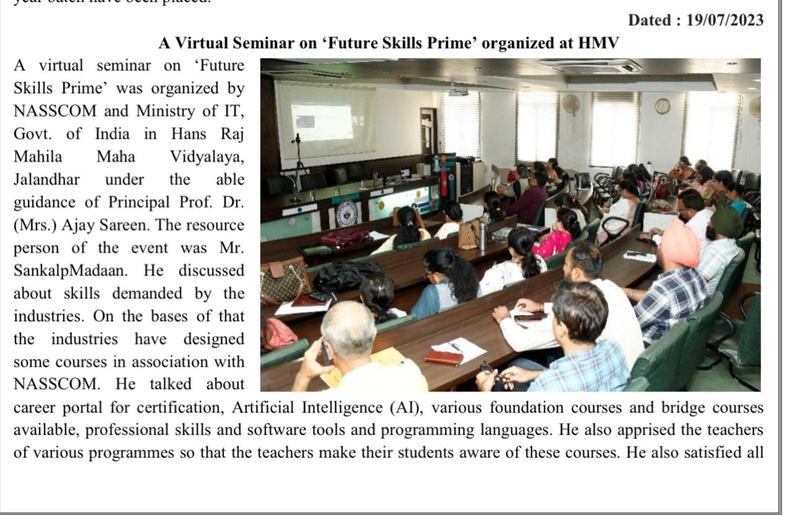

Workshop on Financial Literacy on 22/09/2023

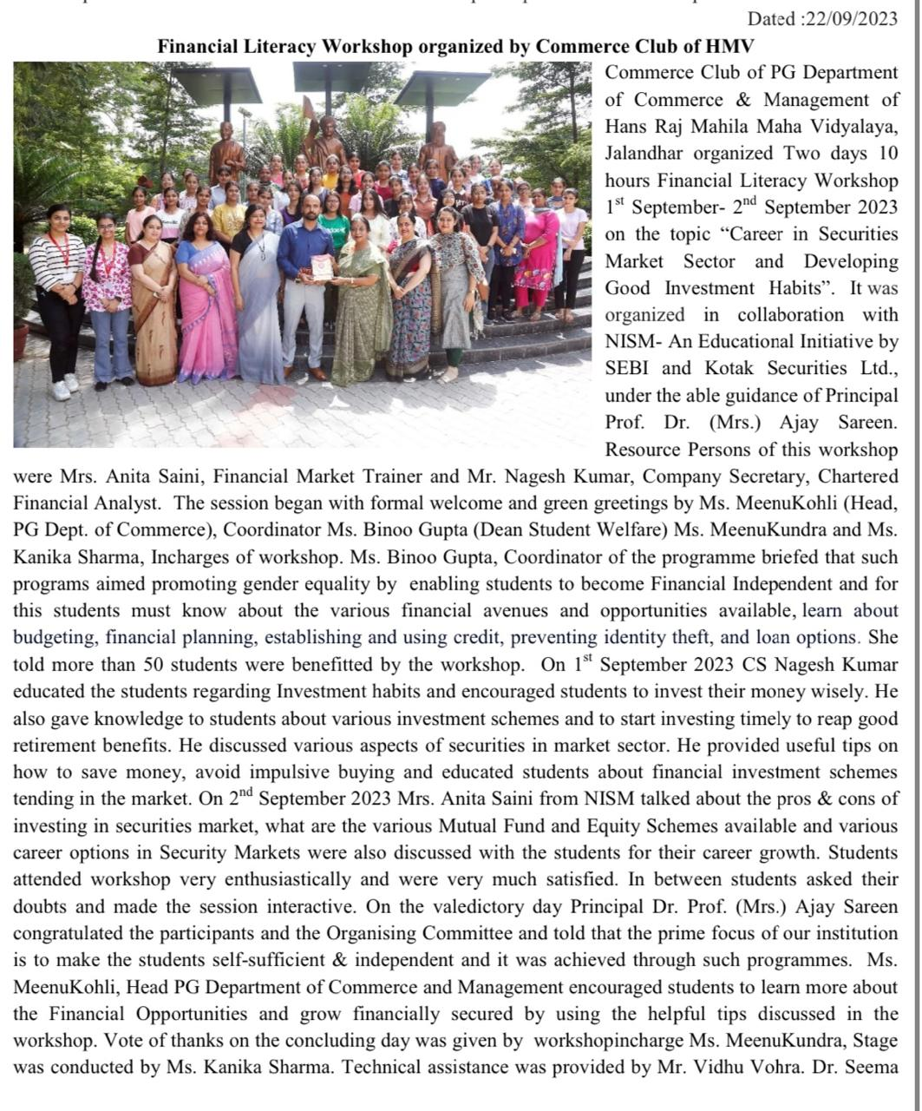

Workshop on Camera Handling Techniques on 13-10-2023

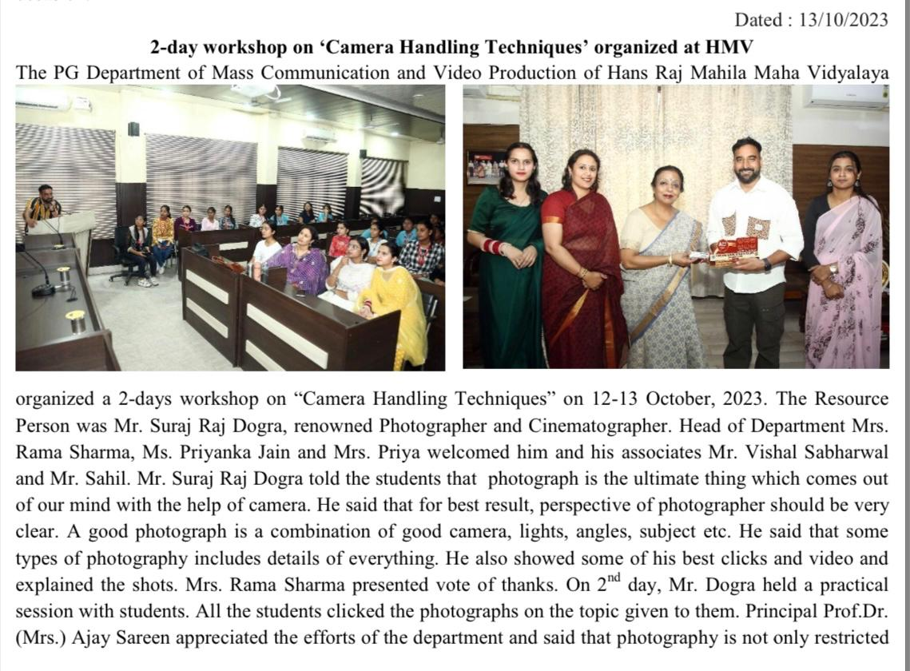

Guest Lecture on UPSC and PPSC Exams on 22-11-2023

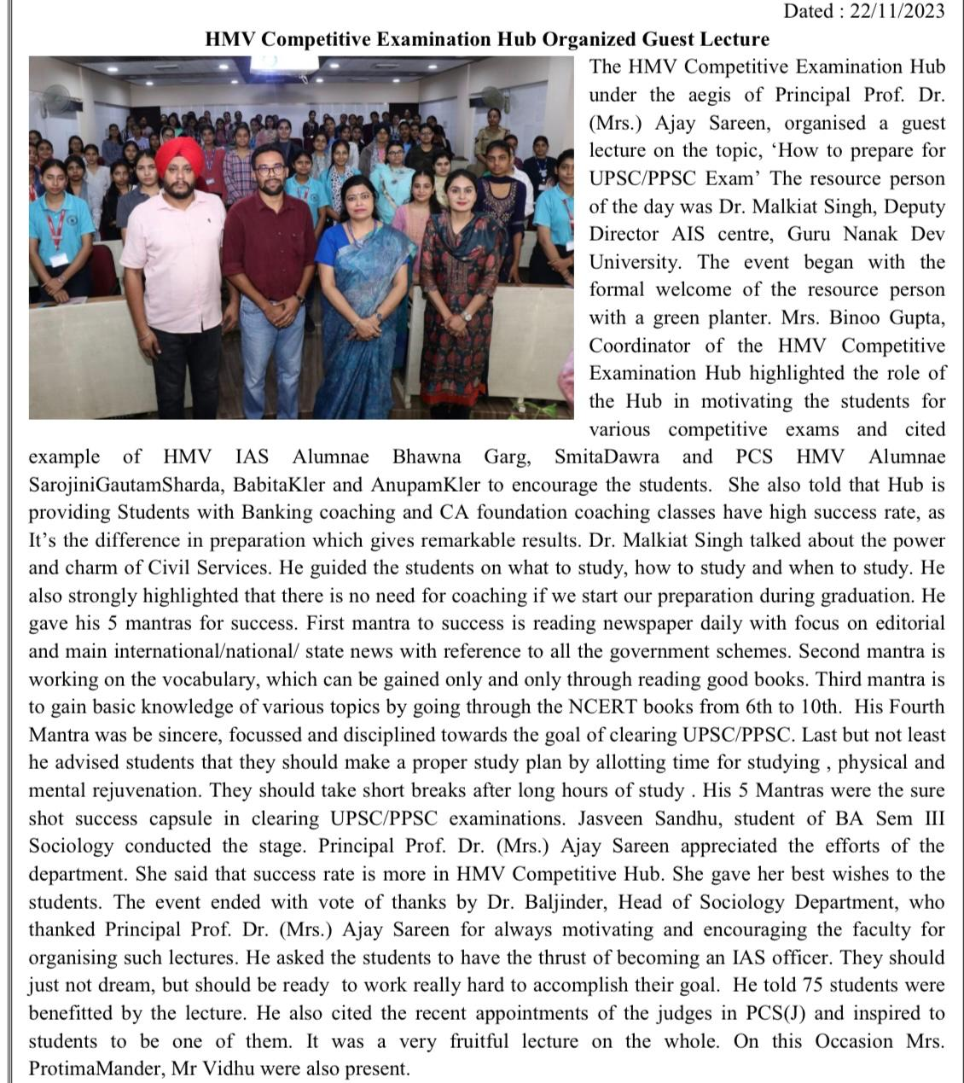

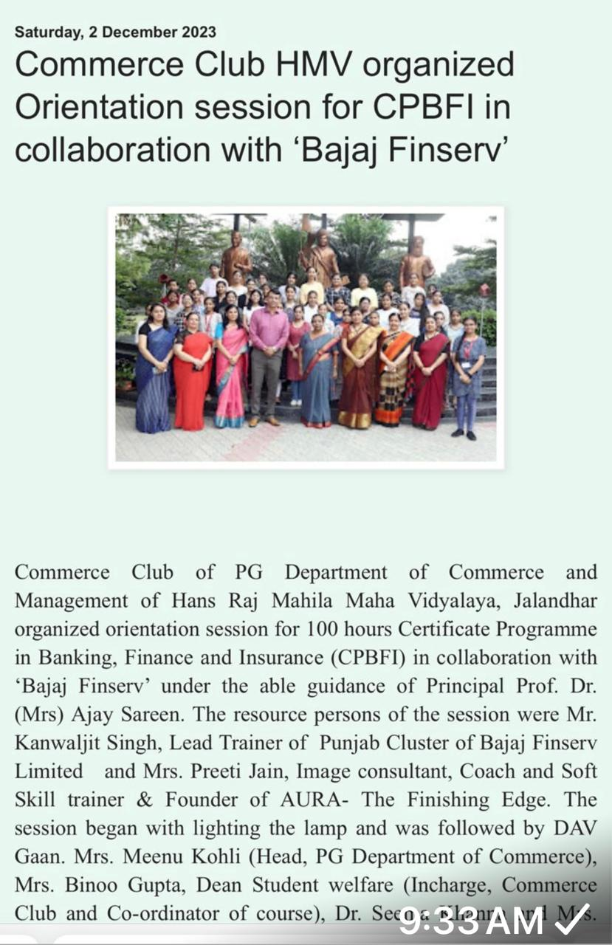
Orientation Session by Bajaj Finserv on 02-12-2023

Career Guidance at SPARK on 15-12-2023

